8

Climate Change

human-induced increases in CO

would be expected to lead to gradual warming of the lower atmosphere

where models currently show more warming in the troposphere than has been observed, and in the Arctic,

2

(the troposphere) and cooling of higher levels of the atmosphere (the stratosphere). In contrast, increases

where the observed warming of the troposphere is greater than in most models.

in the Sun’s output would warm both the troposphere and the full vertical extent of the stratosphere. At

that time, there was insufﬁcient observational data to test this prediction, but temperature measurements

from weather balloons and satellites have since conﬁrmed these early forecasts. It is now known that the

observed pattern of tropospheric warming and stratospheric cooling over the past 40 years is broadly

consistent with computer model simulations that include increases in CO

and decreases in stratospheric

2

ozone, each caused by human activities. The observed pattern is not consistent with purely natural changes

in the Sun’s energy output, volcanic activity, or natural climate variations such as El Niño and La Niña.

Despite this agreement between the global-scale patterns of modelled and observed atmospheric

temperature change, there are still some differences. The most noticeable differences are in the tropics,

In the early 1960s, results from mathematical/physical models of the climate system ﬁrst showed that

natural factors alone cannot explain the observed changes.

provide us with key insights into the underlying causes of climate change and reveal that

The observed warming in the lower atmosphere and cooling in the upper atmosphere

causes of recent climate change?

stratosphere—tell us about the

—from the surface up to the

5

structure of atmospheric temperature

What do changes in the vertical

n Q& A

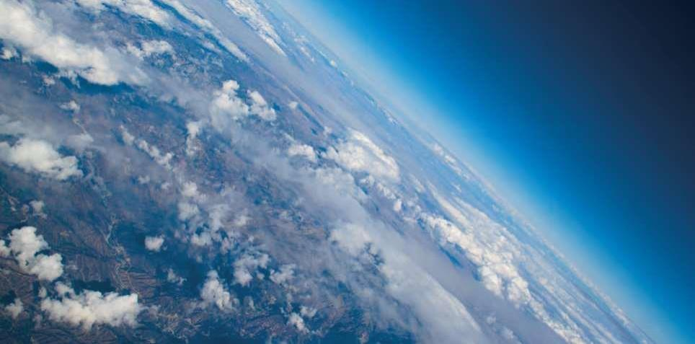

9

7

abundance of CO

and other greenhouse gases, which in turn have ampliﬁed the initial temperature change.

2

Recent estimates of the increase in global average temperature since the end of the last ice age are 4 to

in Earth’s history?

5 °C (7 to 9 °F). That change occurred over a period of about 7,000 years, starting 18,000 years ago. CO

2

has risen more than 40% in just the past 200 years, much of this since the 1970s, contributing to human

alteration of the planet’s energy budget that has so far warmed Earth by about 1 °C (1.8 °F). If the rise in CO

2

continues unchecked, warming of the same magnitude as the increase out of the ice age can be expected

by the end of this century or soon after. This speed of warming is more than ten times that at the end of an

ice age, the fastest known natural sustained change on a global scale.

Is the current level of atmospheric

CO

concentration unprecedented

2

The present level of atmospheric CO

concentration is almost certainly unprecedented

2

in the past million years, during which time modern humans evolved and societies

developed. The atmospheric CO

concentration was however higher in Earth’s more

2

distant past (many millions of years ago), at which time palaeoclimatic and geological

data indicate that temperatures and sea levels were also higher than they are today.

Measurements of air in ice cores show that for the past 800,000 years up until the 20th century, the

atmospheric CO

concentration stayed within the range 170 to 300 parts per million (ppm), making the recent

2

rapid rise to more than 400 ppm over 200 years particularly remarkable

[figure ]

. During the glacial cycles

of the past 800,000 years both CO

and methane have acted as important ampliﬁers of the climate changes

2

triggered by variations in Earth’s orbit around the Sun. As Earth warmed from the last ice age, temperature

continued

Evidence & Causes 2020

ice-age timescales, these gradual orbital variations have led to changes in the extent of ice sheets and in the

magnitude of change in temperature since the Industrial Revolution, nor to act on the whole Earth. On

changes are very small over the last several hundred years, and alone are not sufﬁcient to cause the observed

orbit, which alter the way the Sun’s energy is distributed with latitude and by season on Earth. These orbital

natural cycles have recurred roughly every 100,000 years. They are mainly paced by slow changes in Earth’s

The last few of these

[Figure ].

p.B4), which are cold glacial periods followed by shorter warm periods

The largest global-scale climate variations in Earth’s recent geological past are the ice age cycles (see infobox,

the past events, making it more difﬁcult for human societies and the natural world to adapt.

surface and ocean circulation. The speed of the current climate change is faster than most of

to extinction of many species, population migrations, and pronounced changes in the land

All major climate changes, including natural ones, are disruptive. Past climate changes led

6

climate change of concern now?

Climate is always changing. Why is

Q& A n



10

and CO

started to rise at approximately the same time and continued to rise in tandem from about 18,000

2

been used to reconstruct Antarctic

to 11,000 years ago. Changes in ocean temperature, circulation, chemistry, and biology caused CO

to be

2

temperatures and atmospheric

released to the atmosphere, which combined with other feedbacks to push Earth into an even warmer state.

CO

concentrations over the past

2

800,000 years. Temperature is

For earlier geological times, CO

concentrations and temperatures have been inferred from less direct

2

based on measurements of the

methods. Those suggest that the concentration of CO

last approached 400 ppm about 3 to 5 million

2

isotopic content of water in the

years ago, a period when global average surface temperature is estimated to have been about 2 to 3.5°C

Dome C ice core. CO

is measured in

2

higher than in the pre-industrial period. At 50 million years ago, CO

may have reached 1000 ppm, and

2

air trapped in ice, and is a composite

global average temperature was probably about 10°C warmer than today. Under those conditions, Earth

of the Dome C and Vostok ice core.

had little ice, and sea level was at least 60 metres higher than current levels.

The current CO

concentration

2

(blue dot) is from atmospheric

measurements. The cyclical

pattern of temperature variations

constitutes the ice age/ interglacial

cycles. During these cycles, changes

in CO

concentrations (in blue) track

2

closely with changes in temperature

(in orange). As the record shows,

the recent increase in atmospheric

CO

concentration is unprecedented

2

in the past 800,000 years.

Atmospheric CO

concentration

2

surpassed 400 ppm in 2016, and the

average concentration in 2019 was

more than 411 ppm. Source: Based

on ﬁgure by Jeremy Shakun, data from

Lüthi et al., 2008 and Jouzel et al., 2007.

Is there a point at which adding more

of infrared energy by the atmosphere. Greenhouse gases absorb some of the infrared energy that Earth

CO

will not cause further warming?

2

8

No. Adding more CO

There are also many weaker absorption bands. As CO

to the atmosphere will cause surface temperatures to continue to

concentrations increase, the absorption at the cen-

2

increase. As the atmospheric concentrations of CO

increase, the addition of extra CO

2

2

becomes progressively less effective at trapping Earth’s energy, but surface temperature

will still rise.

Our understanding of the physics by which CO

affects Earth’s energy balance is conﬁrmed by laboratory

2

measurements, as well as by detailed satellite and surface observations of the emission and absorption

emits in so-called bands of stronger absorption that occur at certain wavelengths. Different gases absorb

energy at different wavelengths. CO

has its strongest heat-trapping band centred at a wavelength of 15

2

micrometres (millionths of a metre), with absorption that spreads out a few micrometres on either side.

2

tre of the strong band is already so intense that it plays little role in causing additional warming. However,

more energy is absorbed in the weaker bands and away from the centre of the strong band, causing the

surface and lower atmosphere to warm further.

Climate Change

Data from ice cores have

Figure .

n Q& A

